**MixTox Tool**

**User Manual - 1.0**



Table of Contents

1. General Information 3

1.1 Overview 3

1.2 Objective 3

1.3 Purpose of the Document 3

2. Getting Started 3

2.1. Installation: 3

2.2. Application flow: 6

2.2.1.Compound Details: 6

2.2.2.Overview 17

## General Information

### Overview

The main objective of this tool is to automate the process of environmental risk assessment of mixtures (parent or metabolites; Step 3 or Step 4), for a given combinations of chemicals/calculations. The tool has to calculate the overall mixture concentrations and perform the evaluation of the associated risk based on the appropriate methodology.

The calculated result data has to be exported into .csv type files (following specification).

In order to facilitate the whole process and to allow for easy adaptation to currently ongoing changes in the regulatory environment, the development includes support for processing of concentrations of the individual mixture partners, evaluation of total concentrations and other tasks of “preparatory” nature; import and export of data sets for further processing.

### Objective

Purpose is to develop a MixTox tool to automate the environmental risk assessment process.

### Purpose of the Document

This document enables the users to understand the purpose and usage of the application in an effort less manner. Information about MixTox tool is elaborately explained in the user manual.

## Getting Started

## Installation:

**Steps for installing Mix Tox tool:**

1. Unzip the MixTox tool v1.0.0.rar file and click on **setup.**
2. Click on “Next” button in each screen as shown in below screen shots.

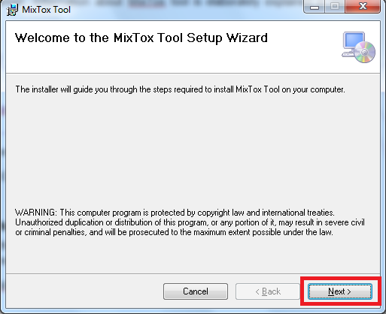

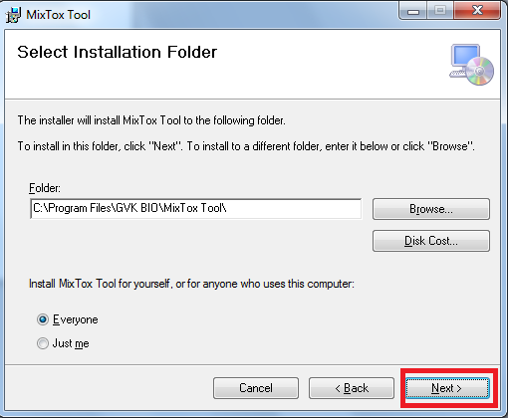

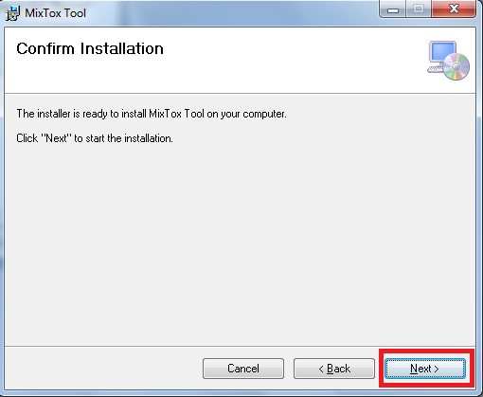

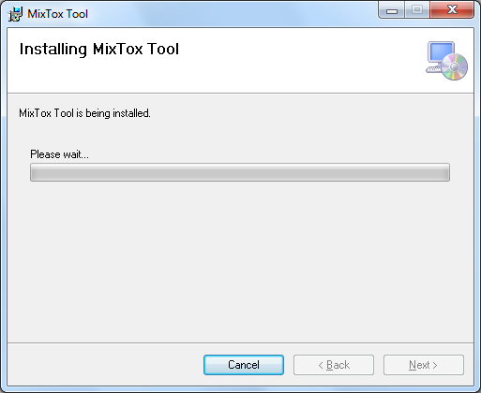

1. Click on Yes to allow installation if system displays a popup window.
2. Click on “Close” button to complete the installation.
3. On successful installation, an icon will be created on desktop as shown below.

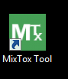

1. User can also find same in Start🡪All Programs🡪MixTox

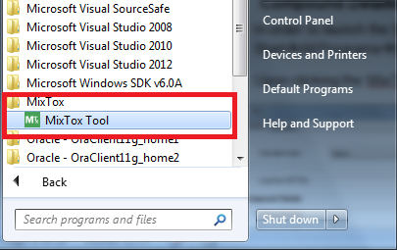

## Application flow:

MixTox tool process is mainly categorized into 2 steps

* Compound Details
* Overview

## Compound Details:

Upon clicking the MixTox tool icon, application is opened and displayed with Compound details as shown in below screen.

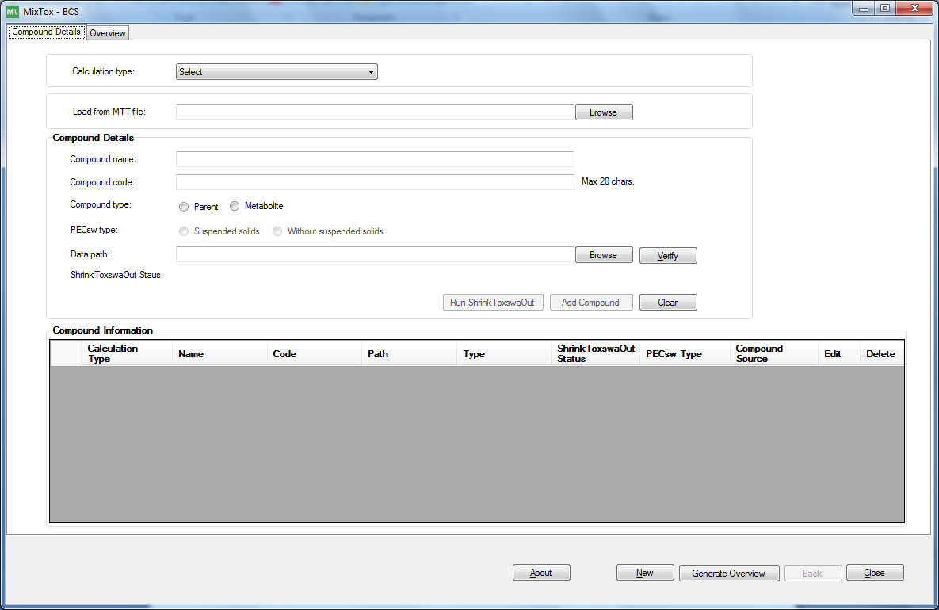

Screen 1

**Add Compound**

In compound details screen, user has option to add compound individually by selecting required parameters in the screen. User also has another option to load compounds using “.mtt” file option “Load from MTT file” which is explained in below section.

**Add compound using compound details fields.**

Using this option user can add individual compound, user has to select required parameters available in the screen.

Steps to Add compound:

1. Select the calculation type ‘FOCUS SW’.

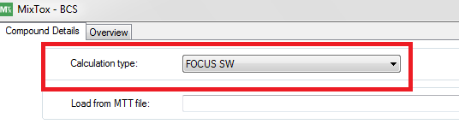

1. Enter compound name.

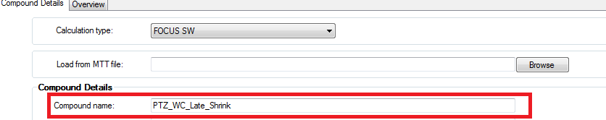

1. Enter compound code (Max 20 characters).

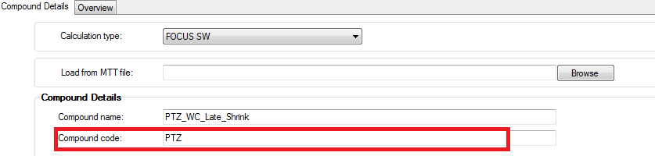

1. Select the compound type (i.e. Parent or Metabolite).

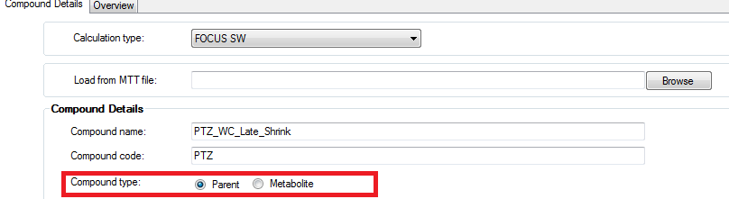

1. Select the PECsw type if the selected calculation type is ‘FOCUS SW’.

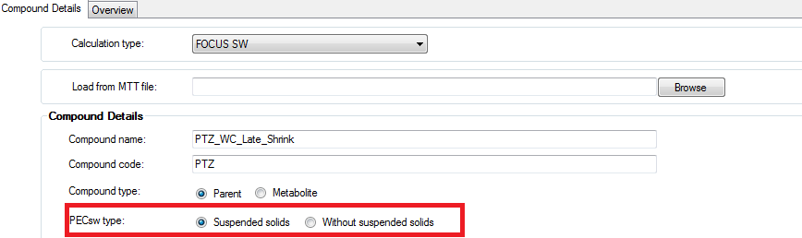

1. Click on ‘Browse’ button in the ‘Data path’ field and select ShrinkToxswaOut tool output files directory path (i.e. swash files path (TOXSWA folder).

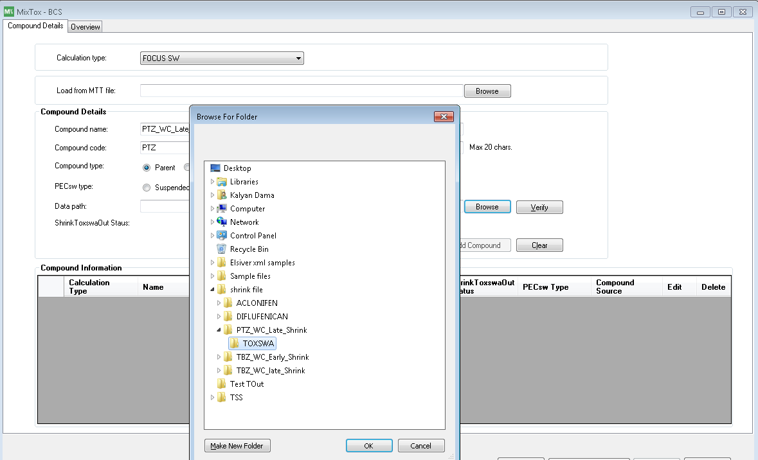

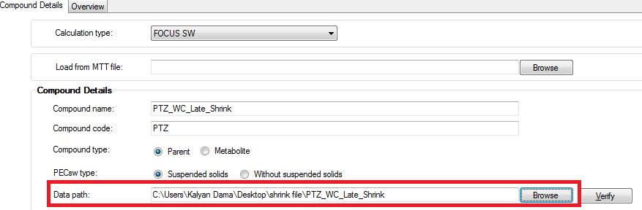

1. Click on verify button, application verifies the below validation and enables the “Add Compound” button as shown below.

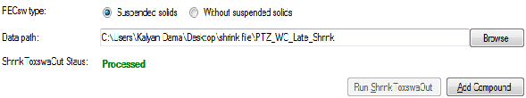

**Validations:**

* 1. Application validates the required fields and values given in compound details section.
  2. Verifies whether ShrinkToxswaOut tool processed or not.
  3. If ShrinkToxswaOut tool not processed, then application displays a message box as ‘ShrinkToxswaOut files (.csv) are not present in selected path’ and also ShrinkToxswaOut status label displays as ‘Not processed’ in red color and Run ShrinkToxswaOut will be enabled.

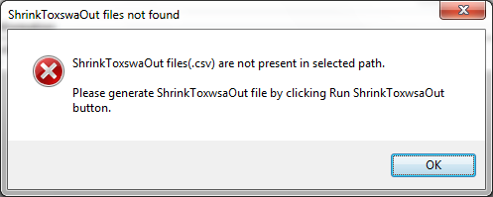

* 1. Click on “Run ShrinkToxswaOut” button to generate csv files.



* 1. Application also checks entered “compound code” matches exactly (not case sensitive) with substance in each csv file. If no match found, tool displays error message box with respective file name(s).

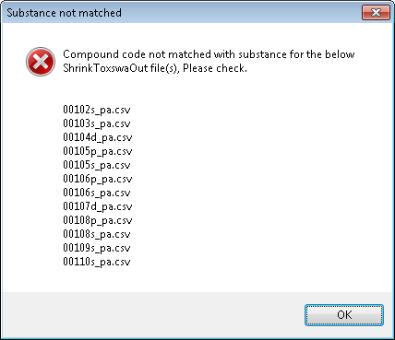

* 1. Application also check for the text ‘N/A’ present in Scenario and water body fields. If found, tool displays error message box with respective file name(s).

1. Click on “Add Compound” button to add a compound. Added compound will be displayed in the “Compound Information grid” as shown below.

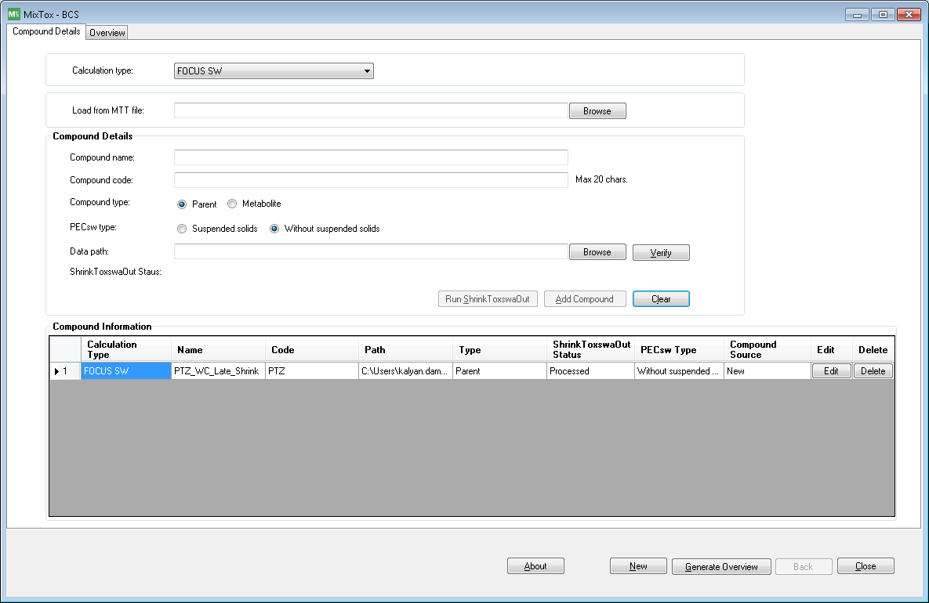

Compounds added to compound information will have option to “Edit” and “Delete” for each compound.

**Edit compound:** Edit compound enables user to modify the added data.

**Steps to “Edit” compound:**

* 1. Click on edit button to modify the added compound.
  2. Compound details will be displayed in respective fields in compound details section and Add Compound changes to Update Compound.

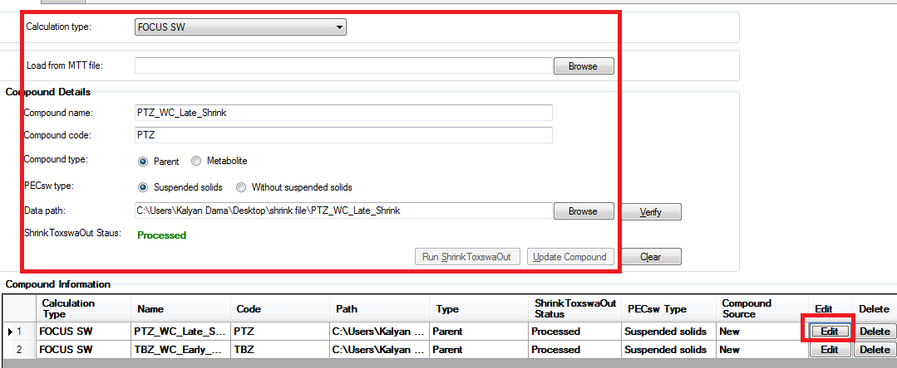

* 1. Modify the desired values and click on Verify button to check validation, once validated click on Update Compound button.
  2. Updated values will be displayed in the compound information grid.

**Delete compound:** Delete enables user to delete added compound. Click on “Delete” button to remove the added compound.

1. **Clear button:** Clear button helps user to clear the compound details in the form.
2. **New button:** “New” button enables user to add new compound details. On click of New button, tool clears all data (i.e. compound details, data in compound information grid and overview summary) as shown in below screen.

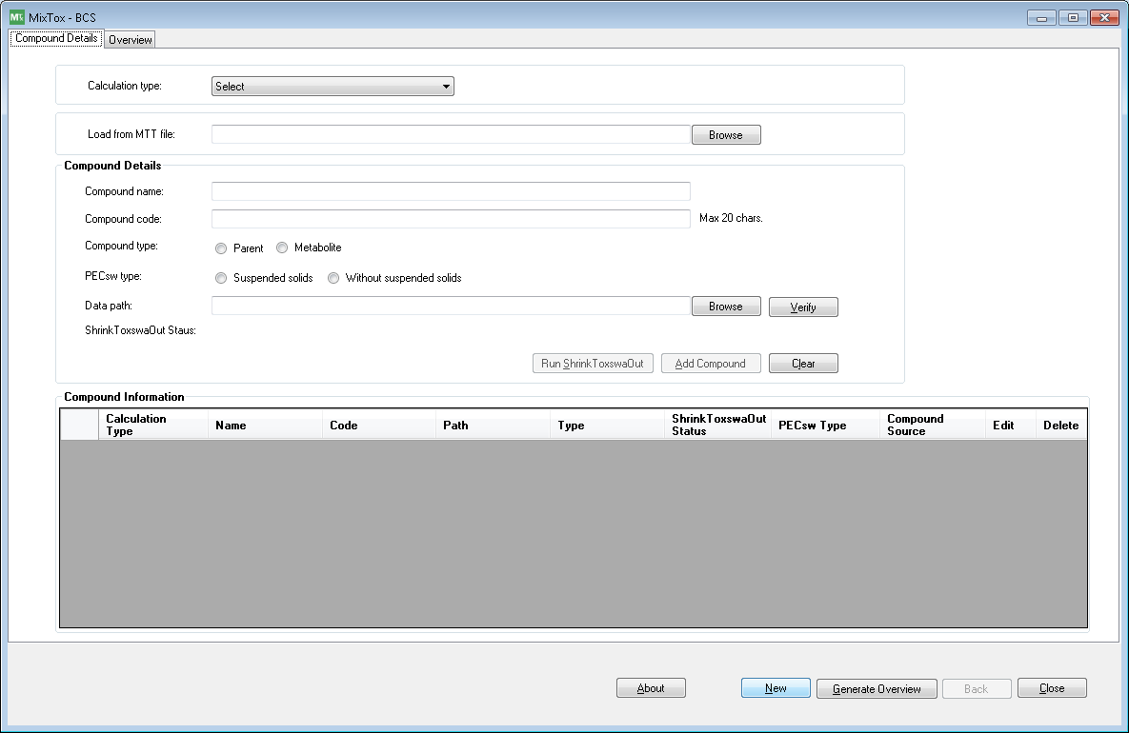

1. **Generate Overview:**

Once user adds required compounds, overview is generated by clicking on “Generate Overview”.

Upon clicking “Generate Overview” button, tool reads “ShrinkToxswaOut” tool’s output files for each compound and generates overview summary data and displays in “Overview” tab as shown in below screen.

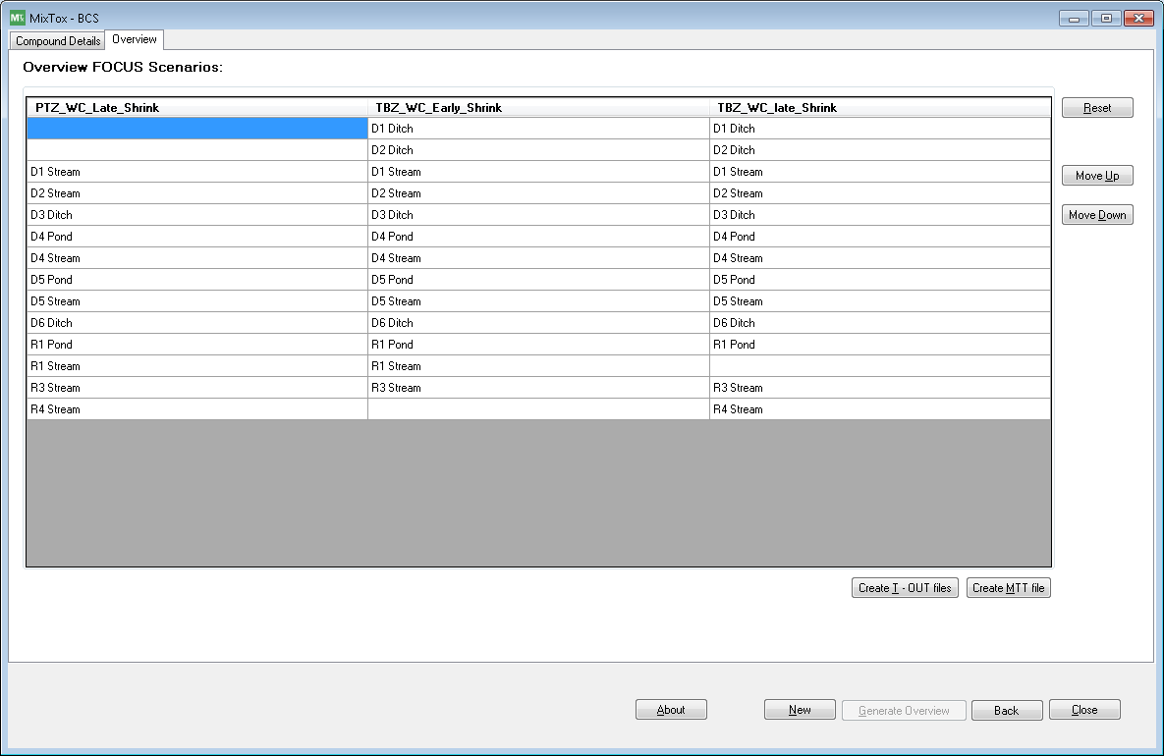

1. **Back button:** On click of this button, tool navigates back to “compound details” tab.

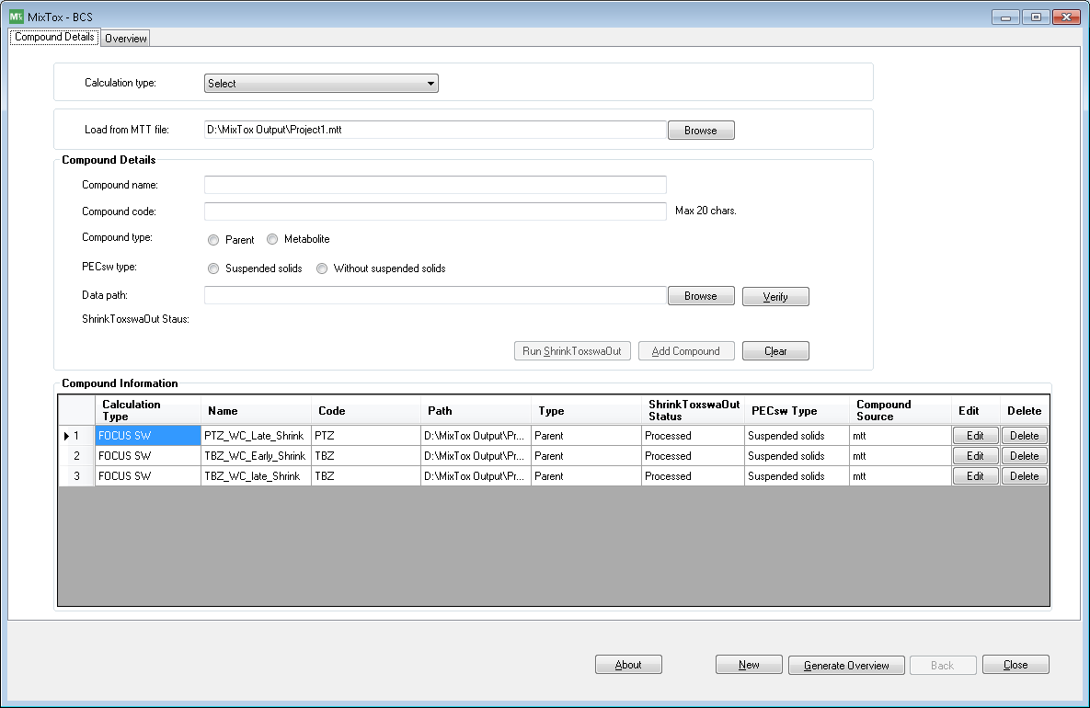

**Add compounds from MTT file:**

1. Select the calculation type.
2. Click on browse button and select MTT (.mtt extension file) file (MTT file creation will be explained later).

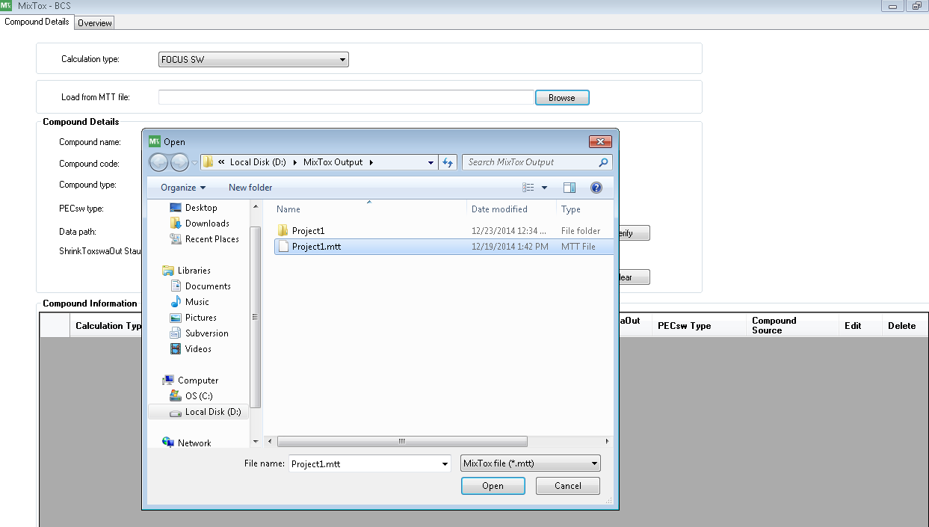

1. Saved compounds will load into “Compounds Information” grid.

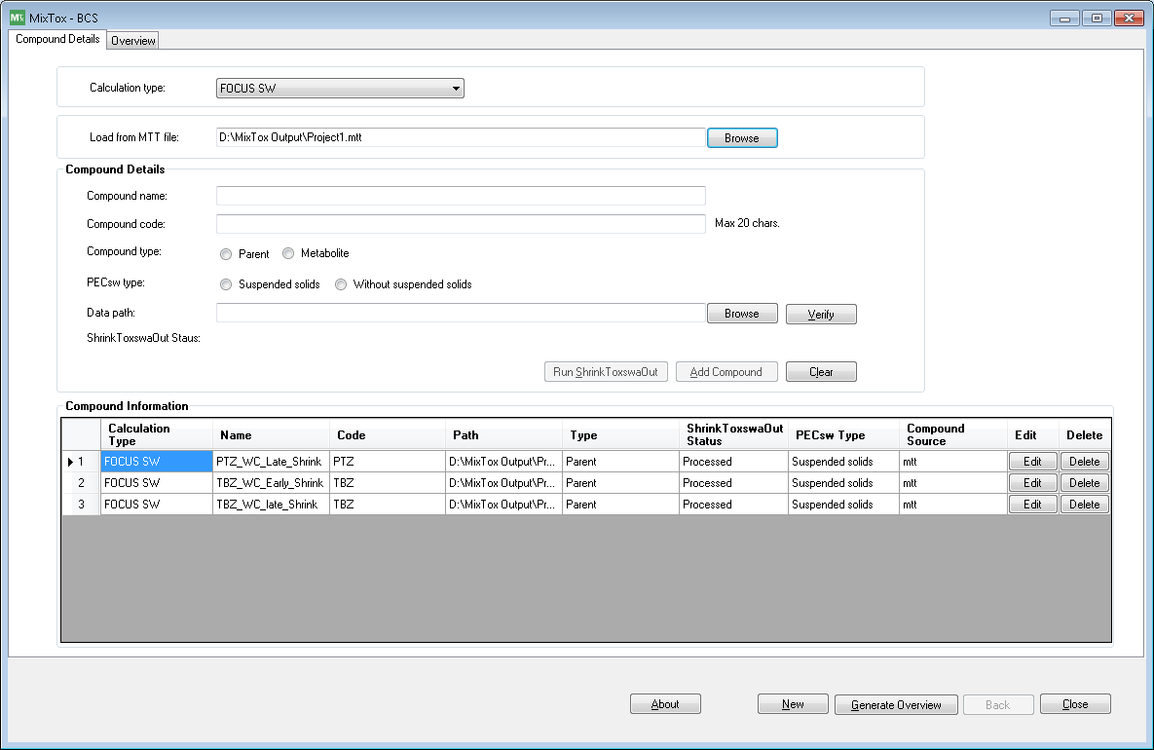

1. For all compounds, compound source will be displayed as “mtt” as shown above screen.
2. User can append/modify/delete any compound, if required.

## Overview

After user has added the compound details and clicks on **“**Generate Overview” button, tool will read the T-OUT files from the selected paths and based on the meta information (i.e. Scenario and waterbody) given in .csv files (output files of ShrinkToxswaOut), tool will try to assign the respective scenario combinations based on this metadata.

1. Compound names will be displayed as column headers and combination of scenario and water body will be displayed under each compound column.
2. If any respective scenario water body file is missed, then it will display empty value in the respective cell.



In overview screen user has options to

**Move Up:** This option allows user to move the selected scenario in upward direction and re-order the scenario.

**Move Down:** This option allows user to move the selected scenario in downward direction and re-order the scenario.

**Reset:** If user changes the order of the listed scenarios, “Reset” option allows loading overview data to default order.

**Create T-Out files:** This option allows user to generate Mixture T-Out files as per the generated scenarios.

**Mixture T-Out file:**

It is an equivalent T-Out file (.csv) presenting unique identifier (i.e. * Filetype,MIX-CONC-MTOUT,0) for this particular calculation and mixture of PECsw, PECsw (suso) and PECsed values on hourly basis without information on individual constituents, as shown in file below



**PECsw/sw (suso)/sed T-Out file(s):**

1. This file(s) will have hourly sum of PECsw components, PECsw (suso) and/or PECsed components, hourly fractions of individual components for PECsw(for individual constituents, the respective value with or without suspended solids will be used) and/or hourly fractions of individual components for PECsed.
2. In addition, maximum PECsw/PECsw (suso)/PECsed values for individual components (together with dates) and their sum will be calculated and maximum mixture concentration should be recorded, together with date and time.
3. Formula for calculating the fraction is (Compound PEC) / (Mixture PEC).
4. Attached the sample output files for reference.



**Create MTT file:**

MTT(MixToxTool) file is a specific file format that is generated by Mix Tox tool. This file contains user selected compound details and overview data. The main objective of this file is to save user defined data and re-use the data for future reference.

Clicking on this “Create MTT file” button, data displayed in the Compounds grid, overview screen and corresponding required file(s) will be saved in MTT file, together with the info on the data assignment. The extension of the file will be tool specific (.mtt), so that this MTT file can be used only by this tool.

**Validations:**

* 1. In grid, a row should display the same scenario and water body. If this validation fails, tool will display error message and also highlights the row background with red color.
  2. Scenario value must be in between D1 to D6 or R1 to R4. If not matched, it displays error message.
  3. Water body value must be in between ‘Ditch, Pond and Stream’. If not matched, it displays error message.
  4. Crop value must contain only values which are listed below. If not matched, it displays error message.

List of crop values in metadata:

1. Cereals_spring
2. Cereals_winter
3. Citrus
4. Cotton
5. Field_beans
6. Grass_alfalfa
7. Hops
8. Legumes
9. Maize
10. Oil_seed_rape_spring
11. Oil_seed_rape_winter
12. Olives
13. Pome_stone_fruit_early_applns
14. Pome_stone_fruit_late_applns
15. Potatoes
16. Soybeans
17. Sugar_beets
18. Sunflowers
19. Tobacco
20. Vegetables_bulb
21. Vegetables_fruiting
22. Vegetables_leafy
23. Vegetables_root
24. Vines_early_applns
25. Vines_late_applns
26. N/A
    1. If “Appln(s)” date value present in .csv file is not similar for all compounds, then display warning message.
    2. If “AppMethod” value present in .csv file is not among the below specified values, then displays warning message.
       1. Aerial
       2. AirBlast
       3. Granular
       4. GroundSpray
       5. SoinIncorp
       6. N/A
27. If validation is successful, folder browser dialog will be displayed to select the location to save output files.
28. Tool creates one mixture file, conc and frac files for PECsw, PECsw (suso) and PECsed columns. So totally it creates 7 files for each valid Scenario and water body combination.
29. Tool ignores scenarios which are not matched for all compounds.